GENDER WISE DISTRIBUTION OF THE TOTAL APPLICANTS FOR THE YEAR 2018
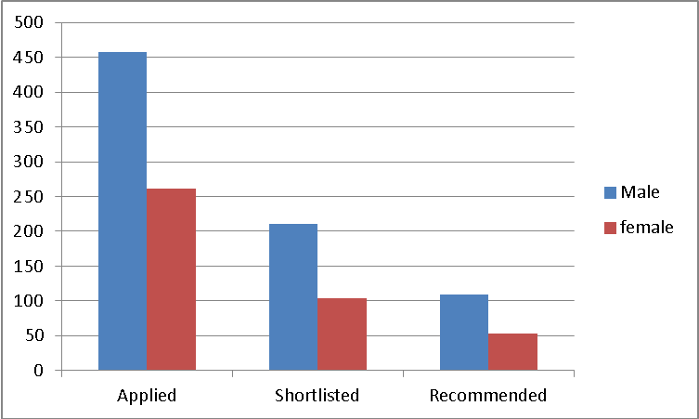
REGION WISE DISTRIBUTION OF THE TOTAL APPLICANTS FOR THE YEAR 2017
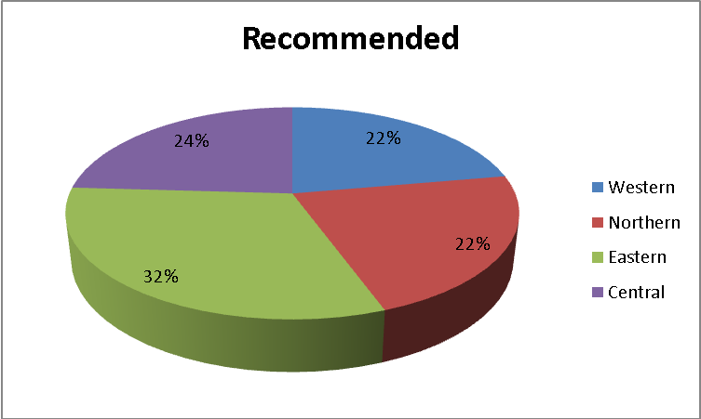
It was may also be noted that the representation from North has increased from 18% last year to 22% this year, whilst East had dropped from 36% to 32%. Central has increased from 17% to 24% and West had dropped from 29% to 22%.

STREAM WISE DISTRIBUTION
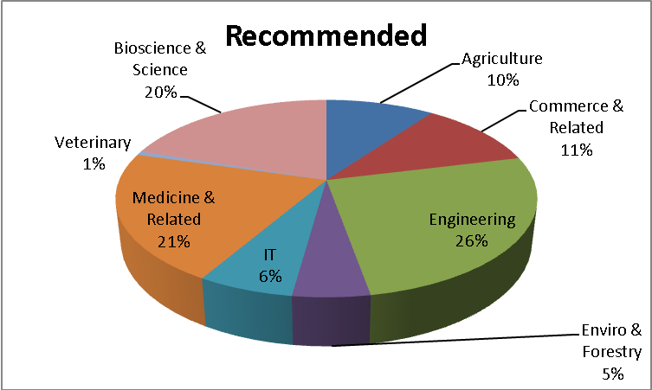

 | Current Year 2018 | Last Year 2017
Total Number of Applications Received | 1322 | 1,293
Applications rejected as they did not meet the short listing Criterion | 605 | 754
Application eligible for short listing for interview | 717 | 539

Numbers | Undergraduate Applicants Current Year | Undergraduate Applicants Last Year | Post Graduate Current Applicants | Post Graduate Applicants Last Year | Total Current Year | Total Last Year
Eligible Applicants | 636 | 438 | 81 | 101 | 717 | 539
Short Listed for Interview | 286 | 316 | 28 | 34 | 314 | 350
Applicants Absent | 4 | 7 | 1 | 1 | 5 | 8
Applicants Attended | 282 | 309 | 27 | 33 | 309 | 342
Applicant Awarded | 149 | 161 | 13 | 15 | 162 | 176
Total Approved Sum | Shs. 650,000,000 | Shs. 650,000,000 | Shs 50,000,000 | Shs 50,000,000 | Shs 700,000,000 | Shs 700,000,000
Scholarship Awarded For | Shs. 652,456,324 | Shs. 670,664,240 | Shs. 60,908,500 | Shs 64,275,000 | Shs. 713,364,824 | Shs. 734,939,240

